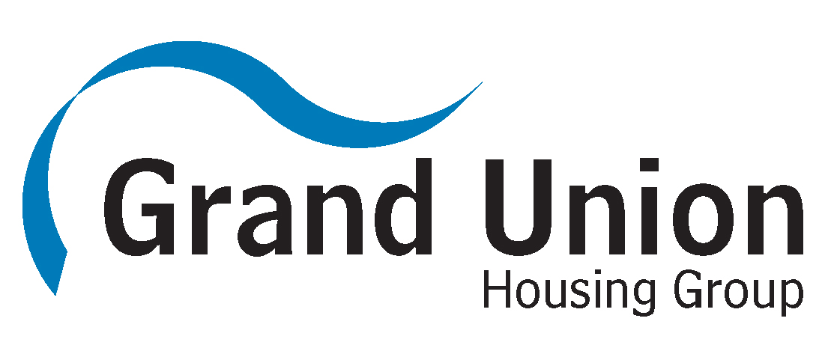

GRANTS
4
YOUR
COMMUNITY

Grants to support community-led or based projects

Application Form

Have you got an idea for an event or project that will benefit your neighbourhood or community but need help funding it?

Grand Union Housing Group (GUHG) may be able to help make it happen through our £500 Grants 4 Your Community (G4YC) grants scheme.

The criteria for grants are:

- They must be from a GUHG resident or community group operating in an area where GUHG has housing stock (if the applicant is under the age of 18 an adult referee is required)

- They must be able to demonstrate that the project / organisation / group will benefit GUHG residents and the wider community

- Grant applicants must be prepared to make a short five minute presentation to our Stakeholder Panel

- Your project / organisation / group must have a bank account (not in an individual’s name)

- Grants are awarded once every 12 months (over a rolling period), per project / organisation / group.

What projects will we consider funding?

We will consider any ideas for projects which:

- Improve community spirit and improve the quality of life for our residents

- Actively involve our residents

- Support fundraising initiatives which benefit the residents of our communities in which they live or work

- Raise the profile of social housing and the importance of housing in people’s lives.

If you have any ideas for a project but are unsure how to go about it, please get in touch with Sasha Childs in the Community Investment Team on:

Tel: 0300 123 5544

or email: sasha.childs@guhg.co.uk

- Your Organisation / Group Details
Organisation / group name:
Project name (if applicable):
Contact person: | Address:
Telephone (landline): | Mobile:
Email:
Organisation website (if applicable):

- About Your Organisation / Group
How long has your organisation / group been operating? |  | Years  Months
Does your organisation / group hold current public liability insurance? |  | Yes / No
Do you or your organisation / group hold current DBS checks for people involved in work with children and vulnerable adults (if applicable to this grant application)? |  | Yes / No
BACS payment details – please give us details of the group / project bank account details (if the grant request is successful):
Account Name:
Account Sort Code:
Account Number:

Please note: If your grant application is successful, one of our officers will attend your organisation / group with a promotional cheque and take photographs.
- About your Project (for which you are applying for grant):
In a minimum of 250 words, tell us the following:
- Where it is located?
- When will it start / how long has it been going?
- Why is it needed?
- What support it has from the local community?
- How will it support GUHG residents and the wider community (if applicable)?
(minimum 250 words)

Approximately how many GUHG residents will benefit from this
project? (This box MUST be completed.)
- Target audience
What ages of people will benefit from the project?

0-14 15-25 26-34 35-44 45-59 60+

Please indicate whom your project mainly serves?

Children and young people Older people (60+)

Women Men

People on a low People with learning
income disabilities

BME communities People with a disability

Unemployed people LGBT

Gypsy / Traveller Faith / religious belief
Group

All Other

If other, please state who:

- Your Grants 4 Your Community application must fall into one or more of the following category/ies, please tick which categories it falls within:
Financial inclusion Health & wellbeing

Social inclusion Employment & volunteering

Skills training Digital inclusion

Other

If other, please state:

- How will you record and monitor the project / activity and its outcomes?
NB- We will require receipt(s) for all purchases and these will be requested no later than 12 months after any grant request has been awarded

- How much are you requesting from our Grants 4 Your Community fund? (maximum funding will be £500, all projects)
£

- Breakdown of grant request

Item | Total cost of items | Funding
 |  | From GUHG | From elsewhere
TOTALS:

- Please list all other funding and fundraising activities which you have carried out to support your project? (including amounts raised):

- Please give any further details you feel would support your application

- How did you find out about Grants 4 Your Community?

Website

SNVB

Word of Mouth

Previous application

Other, please state

Grant terms and conditions

1. Your group / project / organisation will only use the approved grant for the purposes outlined in this application.

2. Your group / project / organisation will not sell or dispose of any equipment or other assets purchased with the grant, without first receiving approval from GUHG.

3. Your group / project / organisation will not use the grant to pay for any goods and services bought or ordered before this grant was approved.

4. Approval of this grant does not imply any further funding from GUHG for this or related projects in the future.

5. Your group / project / organisation will comply with all relevant legislation and insurance requirements when delivering your project with our grant.

6. GUHG will withhold grant or require repayment of it, in whole or in part, if:

a. The application form was completed dishonestly or if any of the supporting documents provide misleading or false information.

b. You or your group / project / organisation does not comply with equal opportunities practice in the way it uses the grant.

7. Your group / project / organisation will acknowledge the GUHG grant in any publicity about your project and agree to GUHG using the project for its own publicity and marketing purposes. We may ask you to take part in informal events to share your experiences with other recipients of receiving a grant from GUHG.

8. Your group / project / organisation will provide receipts for all purchases 12 months from the date the grant was awarded.

9. Your group / project / organisation will allow a photograph of the presentation of your grant cheque to be taken by our Community Consultation Officer and used for publicity purposes (photograph consent forms shall be supplied for completion by everyone in the photograph).

Declaration
I / We can confirm that the individual / group / organisation making this application agree to the above terms and conditions and that I / we are authorised to sign on their behalf.

Name:

Signed:

Date:

Position in organisation:

Contact Tel:

Contact email:

Please return this completed application form to:
Sasha Childs
Community Investment Team
Katherine’s House
Dunstable Street
Ampthill
Beds
MK45 2JP

Grand Union Housing Group comprises:
Aragon Housing Association, Rockingham Forest Housing Association and
South Northants Homes
For office use only:
I confirm that this application meets the required criteria and approve payment of the grant for the sum requested.

Signed Date
Name
Job Title

Signed on behalf of Stakeholder Panel:
Name Date

